Lesson 4 Demo 6: Updating the Rollback Deployment Method

This section will guide you to:

* Update rollback deployment method

This lab has one sub-section, namely:

1. Updating rollback deployment method

**Note:** If you don’t have an existing Kubernetes cluster, refer to the Demo 1.1 of Lesson 1.

**Step 1:** Updating rollback deployment method

* Start the kubernetes cluster in the lab
* A rolling update applies changes to the configuration of pods being managed by a replication controller. The changes can be passed as a new replication controller configuration file; or, if you’re only updating the image, a new container image can be specified directly. So, let’s take an example of applying the update to deployment rolling by editing the configuration file
* If you’ve a pre-existing nginx replication controller from a previous lab, delete it with the command

*kubectl delete replicationcontroller my-nginx*

* Create the following yaml file to run nginx 1.7.9:

*cat > replication-nginx-1.7.9.yaml*

apiVersion: v1

kind: ReplicationController

metadata:

name: my-nginx

spec:

replicas: 5

template:

metadata:

labels:

app: nginx

spec:

containers:

- name: nginx

image: nginx:1.7.9

ports:

- containerPort: 80

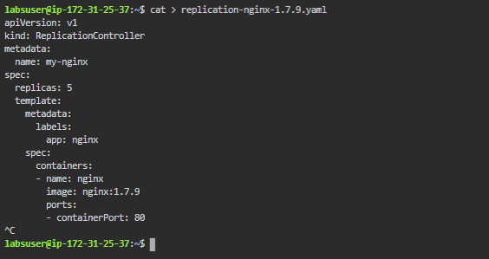

* Submit the ReplicationController to Kubernetes cluster using **kubectl** command as shown below:  
  *kubectl create -f replication-nginx-1.7.9.yaml  
  *
* To update to version 1.9.1, you can edit the deployment and change .spec.template.spec.containers[0].image from nginx:1.7.9 to nginx:1.9.1
* Once edited you can submit the updated yaml to Kubernetes cluster using **kubectl apply -f replication-nginx-1.7.9.yaml** command
* You can see the rollout status as shown after applying below changes:
* *kubectl describe replicationcontrollers/my-nginx*